**Career Hub App**

Final Year Project Proposal

Bachelor of Science in Software Engineering

By

|  |  |  |  |  |
| --- | --- | --- | --- | --- |
| Sr# | Name | Roll no | Mobile no | Email |
| 1 | M. Haseeb | Fa-2018/BSSE/068 | 03034242161 | uhaseeb731@gmail.com |
| 2 | Sehar Naveed | Fa-2018/BSSE/064 | 03129416605 | Seharnaveed341@gmail.com |

**Supervised by:**

Mam Zarsha Nazim **___________________ (Signature)**



**Department of Software Engineering**

**Lahore Garrison University**

**Lahore**

**Career Hub**

**Abstract:**

Selecting the best and suitable career is a crucial decision for students to enhance their learning skills and participate in emerging fields of life. Career selection once done wisely goes long way as it determines a path for a student to follow and achieve desired goal. Most of the students that take right decision for their professional career fail due to lack of Career Counselling. Career counselling services are there to facilitate students in choosing most suitable career but unfortunately, lack of awareness at students' end is the hurdle. On the other side, Career Counselors aren't well-equipped with knowledge of ever-changing and evolving professional fields which hinders the process of effective and helpful counselling. Career Hub is a third-party app that will act as an intermediate between students and instructors. It is a platform for students to get information about the career options they are looking into and also directions to follow the specific path with the help of recommended courses, books and certifications.

**Introduction:**

Career Hub is a student career recommendation third-party website that uses Natural Language Processing and Deep Learning to recommend the right career for the students on the basis of interests, skills, previous academic record and psychology of students. A full-stack application which will use natural language processing(NLP) data model to predict the best career once he create account, upload the transcript/marksheet of his previous academic record and answer the questionnaire related to skills and interest. Students will be able to get the related courses, books and certifications after selecting the career they are going to follow. On the other hand there will a dashboard for the instructors where they can create account and upload the courses and books for the students. Students can also visit the profile of the instructors to check out new updates and announcements. An additional feature will be an admin portal providing latest news and blog-posts related to different universities, their admission opening information and admission test-patterns.

**Working:**

Basically the main working of the app relays on natural language processing (NLP) and deep learning concept. After login, student has to upload image of his transcript/detailed mark sheet of Matric or Intermediate result consisting of all the obtained marks and percentage. OpenCV an image processing library that will process the image of transcript and fetch all the academic details including subject name, obtained subject marks, total subject marks, overall obtained marks and overall total marks. On the other hand this app will provide a questionnaire to the students in the form of dropdown options from where they can select the most suitable answers that helps to analyze the skill level and interest. A natural language processing (NLP) model is designed that takes these values and predict a list of careers that frequently matches the student input details. After getting a list of recommended careers, Students are being able to choose the right option. Students are also provided with the courses that will help them to enhance their skills in a way to achieve career goals.

**Project Scope:**

Early on in academic life, every student must set a target and map-out his steps towards the goal he wants to achieve. Choosing the right career is a decision that is pivotal in this process. The sole purpose of this web-based app is to facilitate that very decision. It is user-friendly, saving the students from hassle of technicalities of technology. Top of all, they can find motivation out of success stories of some field experts in this app.

**Problem Statement:**

There is always a difficulty for the students to choose their career that will help them to build their professional skills. Many students are not being able to judge themselves and they didn’t consider their abilities that cause an impact on their career. Career Counsellors are there to guide the students about the profession based on their interests but they don’t provide them the content that is going to be helpful for them to achieve the career goals. Secondly, many students who are determined about their career didn’t find any authentic content related to their career that is helpful for them, most of the content available on the web didn’t polish your skills it just wastes your time.

**Related Work:**

No Such work is done earlier on just blog post websites are developed

**Features:**

|  |  |  |
| --- | --- | --- |
| **Instructor** | **Admin** | **Student** |
| * Instructor can sign up and login into the system * Instructor can add new courses, content and books. * Instructor can schedule live sessions with the students. * Instructor can set up his profile so that it will be easy for the student to analyze instructor professionality’s. | * Admin can login into the system * Admin can display details about different admission openings, entry tests, admission details etc. | * Student can create an account and login * Student can upload their transcript and fill the questionnaire to get a list of recommended careers * Student can access the courses and content uploaded by the instructors and also the information by the admin. * Students can save their courses for later access. |

**Tools and Methodologies:**

* **Frontend Web Development (HTML/CSS/Bootstrap/JavaScript)**
* **Backend Web Development (Django Web Framework)**

Visual Studio Code is a source code editor developed by Microsoft team that support different type of backend and frontend development libraries, programming tools, and code snippets and embedded Git. It is a simple, lighter and easy to use software especially used for web development purposes. It includes a great functionality of build-in server that helps to run a website easily on local server. It also support most all the features and libraries for Django development (web framework of Python). It includes a build-in database dbsqllite3 for handling user and admin data.

* **Database Development (MySQL and MySQL lite)**

MySQL is an open-source relational database management system to create database and to create, update, delete and view data in the tables.

* **Natural Language Processing and Deep Learning (Anaconda Navigator)**

Natural language processing is a subfield of artificial intelligence concerned with the interactions between computers and human language, in particular how to program computers to process and analyze large amounts of natural language data. We are going to use Natural language processing to predict the career for the students from a various amount of natural data. Deep Learning is a part of machine learning methods that are based on artificial neural networks. It comprises of multiple layers to extract high-level features from raw input.

**Nltk:**

The Natural Language Toolkit, or more commonly NLTK, is a suite of libraries and programs for symbolic and statistical natural language processing for English written in the Python programming language.

**Nltk.corpus:**

The modules in this package provide functions that can be used to read corpus files in a variety of formats.

**Wordnet:**

WordNet is the dictionary for the English language, specifically designed for natural language processing. Synset is a special kind of a simple interface that is present in NLTK to look up words in WordNet.

**OpenCV:**

OpenCV (Open Source Computer Vision Library) is an open source computer vision and machine learning software library. OpenCV was built to provide a common infrastructure for computer vision applications and to accelerate the use of machine perception in the commercial products. We are going to use image processing library of OpenCV to process the images of transcript.

* **Mobile Application Development (Android Studio)**

Android Studio is the official integrated development environment for Google's Android operating system used to develop android based applications. It comes with an intelligent code editor, flexible build system, realtime profilers and emulators. Mobile Application of our project is based on Android Studio.

**Project Milestones:**

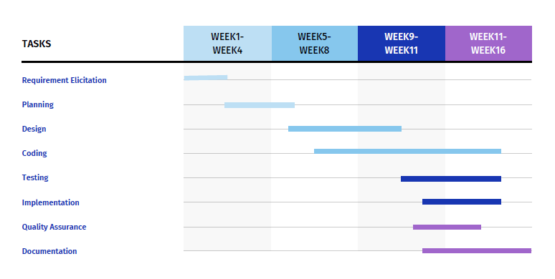**Gantt chart**

**Conclusion:**

The whole study concludes that career hub will help student to choose career wisely from the recommendation provided by the expert opinions and anyone who is aiming to achieve his goals can easily follow the path of career by exploring different courses, books and certifications. Students can get the latest updates regarding the admission opening in different universities, entry test information and eligibility criteria.

**References:**

* https://www.ilmkidunya.com/
* http://www.entrytest.com/
* https://www.coursera.org/
* https://www.udemy.com/
* https://www.udacity.com/

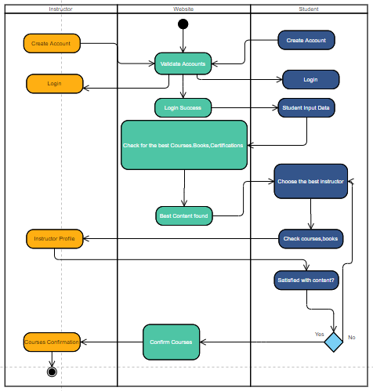**Activity Diagram:**